**Workshop – Black Box Testing**

**Question1: Boundary Value Analysis**

Assume, we have to test a field which accepts Age 18 – 56



**How many test cases should be checked here?**

**Your answer:**

Min boundary value - 18

Max boundary value – 56

Valid Inputs-18,19,55,56

Invalid Inputs-17 , 57

Test cases

1. Enter the value 17 - invalid

2.Enter the value 18 -valid

3.Enter the value 19 -valid

4. Enter the value 55 - valid

5. Enter the value 56 -valid

6. Enter the value 57 -invalid

|  |  |  |
| --- | --- | --- |
| **Invalid inputs 17** | **19, 55 Valid inputs** | **57 Invalid inputs** |

**18 56**

**Question 2: Equivalence partitioning**

In an Examination, a candidate has to score a minimum of 24 marks in order to clear the exam. The maximum that he can score is 40 marks.  Identify the Valid Equivalence values if the student clears the exam. Please draw also valid and invalid partitions.

a)    22,23,26  
b)    21,39,40  
c)    29,30,31  
d)    0,15,22

**Your answer:**

|  |  |  |
| --- | --- | --- |
| Invaid inputs <24 | 25,26,27,….37,38,39 valid inputs | 40< invalid inputs |

24 40

The answer is c.)29,30,31

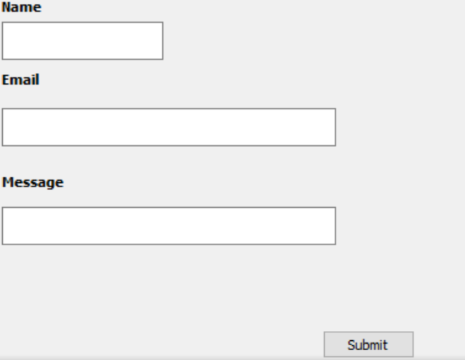**Question 3: Decision table**

**Submit button in Contact Form is**

**enabled when all the inputs are entered by the end user.**

**Your answer: Make decision table with T/F**

|  |  |  |  |  |  |  |  |  |
| --- | --- | --- | --- | --- | --- | --- | --- | --- |
|  | **Test Case1** | **Test Case2** | **Test Case3** | **Test Case4** | **Test Case5** | **Test Case6** | **Test Case7** | **Test Case8** |
| **Name** | **F** | **T** | **F** | **T** | **F** | **T** | **F** | **T** |
| **Email** | **F** | **T** | **T** | **T** | **F** | **F** | **T** | **F** |
| **Message** | **F** | **T** | **F** | **F** | **T** | **T** | **T** | **F** |
| **Submit** | **F** | **T** | **F** | **F** | **F** | **F** | **F** | **F** |

**correct inputs –True**

**incorrect inputs-False**

**Question 4: State Transition table**

Login page of an application which locks the user name after three wrong attempts of password.

**Your answers**

1. **Draw State Transition Diagram**

pas

Pass pass

fail

pass successfully logged in

fail

pass

In the diagram the user enters the correct PIN he is moved to “Home” state, and if he enters the wrong password he is moved to next try and if he does the same for the 3rd time the account is blocked.

Pass-correct Pin

Fail- incorrect Pin

1. **Make State Transition table**

|  |  |  |  |
| --- | --- | --- | --- |
| **State** | **Login** | **Correct Password** | **Incorrect Password** |
| S1 | First attempt | S4 | S2 |
| S2 | Second attempt | S4 | S3 |
| S3 | Third attempt | S4 | S5 |
| S4 | Home Page |  |  |
| S5 | Account blocked |  |  |

All exercises are solved correctly, good for you 😊